**Getting Started!**

1. **Overview:** A brief introduction of the course; very general.

Risk Management is an integral part of project management. It reduces threats to a suitable level while improving opportunities. Projects today have more administrative and technical constraints, and are less likely to have adequate resources than in the past. These situations create uncertainties, which generate risky events that managers have to learn to deal with. To properly develop a project risk management plan, we should first understand the nature of “risk.” Implementing an effective risk management plan and recognizing the underlying factors that contribute to these events is a key factor in understanding uncertainties and risks.

This course introduces the latest guidelines on Project Risk Management based on recommendations from the Project Management Institute (PMI) and other professional and academic establishments. The course has been designed for managers that need to improve their knowledge and understanding of project risks and effectively plan responses and control approaches for real-world applications in the private or public sector. Through different techniques, the student will learn how to plan, assess and prioritize risks, develop adequate risk response strategies, implement, monitor and control plans and deliver projects that fulfill stakeholder expectations.

**Student’s profile:**

**Pre-requisite competencies necessary for enrollment.**  Comprehensive knowledge on use of the interphase platform (Moodle).

Problem solving skills in basic project management

* Understand PMI’s areas of knowledge: communication, time and cost.

Basic knowledge in statistics

* 1. **Competencies obtained upon completion of course**.

The student will be able to :

* Explain the risk management process as defined by the PMBOK® Guide
* Discuss the process of developing a risk management plan and a risk register.
* Understand key processes in the Risk Communication domain, including documenting risk information and assessing stakeholder risk tolerance
* Understand key processes in the risk analysis domain, including identifying and evaluating relevant risks and their potential impact
* Explain key tools and techniques employed in the qualitative and quantitative analysis of risk
* Understand key processes in the Risk Response Planning domain, including developing risk response strategies and contingency plans and managing stakeholder expectations
* Comprehend best practices in all aspects of risk management.

1. **Mind map**

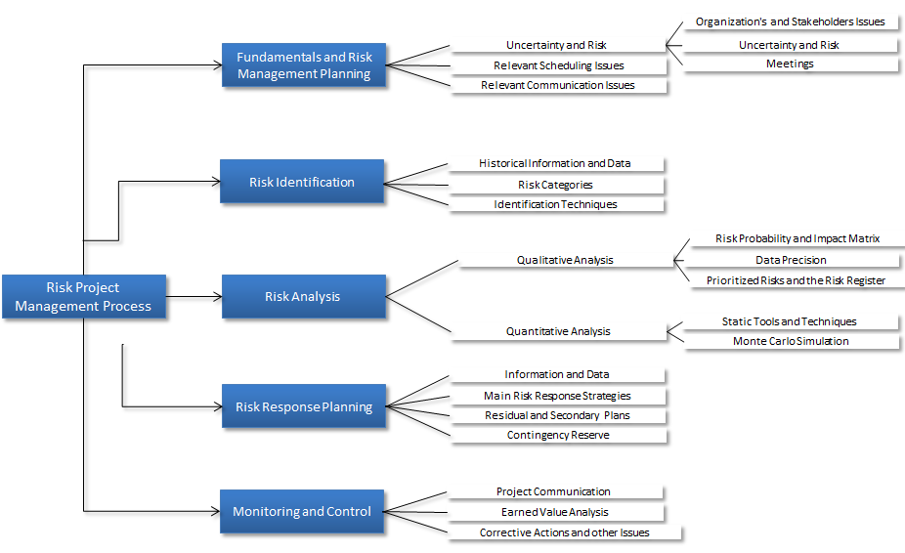

1. **Content:** A list of the main contents the course will cover

* Project Risk Management Plan
* Project Risk Register
* Stakeholder risk tolerances
* Risk identification
* Risk response strategies
* Information gathering techniques
* Diagramming techniques
* Risk Breakdown Structure (RBS)
* Qualitative risk
* Probability and Impact Rating and Matrix
* Quantitative risk
* Sensitivity analysis
* Decision Tree analysis
* Monte Carlo simulation
* Risk monitoring and control
* Prioritizing risks
* Residuals and secondary risks
* Corrective actions and Triggers

1. **Guidelines:**
   1. The main study resource for each module is chapter lectures from the textbook “*Project Risk Management: The Most Important Methods and Tools for Successful Projects*” (2013) by Roland Wanner, and the PMBOK (Version 5.) The assigned lectures will guide you through the fundamentals you need to master for each learning objective. At the end of each module, you will be required to take a multiple choice and true-or-false quiz, designed to validate and reinforce your knowledge about key module’s topics.
   2. Student, professor and academic assistant expectations

Student:

* + - * 1. Study all assigned chapter lectures.
        2. Keep in regular contact with the instructor.
        3. Complete the assignments and final test on time.

Professor:

* + - 1. Assist the student in his/her studies.
      2. At the conclusion of the course, send an evaluation and final grade to UCI Registrar’s Office
      3. Provide adequate feedback to the student in a reasonable amount of time.
      4. Where is Academic Assistant’s info?
  1. : Explanation of activities

Main Module Activities:

* Lectures: At least one chapter from the textbook per week.
* One quiz each week ) Important and highly recommended, but will not count toward final grade
* A comprehensive Final Test
* Forum: Two questions will be posted at the end of week 2 and week 4 for student interaction. Participation is not mandatory.

1. **Evaluation:** Course grading

The course requires approximately ten hours a week of dedication and hard work. Each week the course focuses on a different aspect of the project risk process, with a strong focus on the application in practice.

Participants are required to demonstrate satisfactory achievement of the course objectives through a final comprehensive test of 50 questions (multiple choices and true-or-false.)

**Bibliography**

* Barkley, Bruce (2004). Project Risk Management. New York, McGraw-Hill Professional.
* Bart, Jutte (2009). Project Risk Management Handbook: The invaluable guide for managing project risks. Delhi, India: Mantaba Publishing
* Cooper, Dale F., Grey, Stephen, Raymond, Geoffrey, and Walker, Phil (2004). Project Risk Management Guidelines: Managing Risk in Large Projects and Complex Procurements. Hoboken, NJ: Wiley
* Ghantt, Thomas (2012). Project Risk Management: Using Failure Mode Effect Analysis for Project Management. Lowellville, OH: Plumbline Publishing Group
* Hillson, David & Simon, Peter (2012). Practical Risk Management: The ATOM Methodology. Leesburg Pike, VA: Management Concepts Press
* Kendrick, Tom (2009). Identifying and Managing Project Risk: Essential Tools for Failure-Proofing Your Project. Toronto, ON: AMACOM
* Raydugin, Y. (2013). Project Risk Management: Essential Methods for Project Teams and Decision Makers. Hoboken, NJ: Wiley
* Wanner, Roland (2013). Project Risk Management: The Most Important Methods and Tools for Successful Projects. New York, NY: CreateSpace Independent Publishing Platform.

**Week 1**

1. **Main Topic**

Projects have many sources of uncertainties, which could cause risky events to flourish. These sources arise for many reasons, such as inaccurate scope definition, flaws in establishing appropriate project activity parameters (e.g., task dependencies, task durations and resource constraints), ineffective stakeholder management and external unforeseen events. It is impossible to conceive a project without risks and a well-managed project without institutionalized risk management practices, which will provide a consistent methodology for performing project risk management activities. In fact, preparing for risks is the best defense against project tragedies.

Project risk management is the process of planning, identifying, analyzing, responding, monitoring and controlling risk factors throughout the life cycle of a project. Its strategic goal is improving the prospect that the project’s objectives will be accomplished as planned., Professional organizations are recognizing that risks in projects could be beneficial. In fact, PMI defines project risk as “…an uncertain event or condition that, if it occurs, has a positive or negative effect on one or more project objectives such as....” Therefore, this is a proactive process which implies influencing possible future events, so that threats and opportunities are optimized.

In a nutshell, by evaluating plans for potential problems and developing strategies to address them, the project team can improve the chances of a successful, if not perfect, project closing. An effective project risk management process should identify individual risk events within the project and enable them to be managed appropriately, and should also provide an indication of overall project risk exposure.

1. **Mind Map**

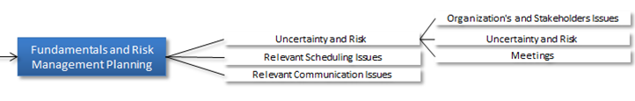

1. **Learning Objectives**
   * + - Discuss the effect of uncertainty and risks events on project performances
       - Understand the project risk management processes
       - Explain how stakeholders risk tolerance, organizational structure and communications influence the project risk management process
       - Discuss how project risk management fits into the overall project management process
2. **Content**
   1. Project risk management process
   2. Risk management plan
   3. Stakeholder’s risk tolerances
   4. Scheduling and communication issues upon risks
3. **Step by Step**

Study the following:

Textbook

Chapter 1: Introduction

Chapter 2: Why Risk Management?

Chapter 3: The Risk-Management Process

PMBOK

Chapter 10, sections: Introduction & 10.1

Chapter 11, sections: Introduction & 11.1

1. **Lesson summary**

This module provides the basics to understand the nature of risks and the risk management process in projects, and is a primer on the essence of risks and risk management from a practical perspective. Understanding a risk and the risk management process entails understanding the underlying factors that contribute to project risks. Therefore, the module begins exploring the concept of risk (e.g., uncertainty, causes, and events) and its multi-dimensional attribute. This will frame key concepts that will be used in module 2 and 3, where risks will be unbundled for clear understanding of its nature. Although risks differ according to types of projects, there are some fundamentals that apply to all projects. Often, risks are described in statistical terms. A key issue throughout the module is that in project management even though most of the time the term risk has a negative connotation; it could also represent a potential opportunity.

Moving to the risk project management process, an approach based on PMI’s PMBOK (Version 5) is introduced: The process covers Risk Management Planning, Risk Identification, Risk Analysis, Risk Response Planning, Monitoring and Control, and Communications. Overall considerations that need to be taken into account before engaging in the risk management process are presented. The module ends with a justification of the need to institutionalize- risk management initiatives into the project management process

1. **Self-assessment**

There will be a multiple choice and true-and-false (13 questions) quiz.

**Week 2**

1. **Main Topic**

The risk identification process is a key step in a comprehensive and continuous risk management method to enhance the probability of project success. PMI states that “...risk identification involves determining which risks might affect the project and documenting their characteristics.” The main two steps in this process are risk classification and categorization. They enable the project team to focus their attention on risks with high significance, search common causes and create watch-lists for low priority risks.

There are numerous techniques for expediting the systematic and repeatable identification of risks (i.e., checklists, brainstorming questionnaires SWOT analysis, force-field-analysis, nominal group techniques and diagramming approaches) associated with a project. There is no best-method, and most of the time the project team will be required to use a combination of techniques. After the risks have been identified, they have to be categorized.

There are many risk categories that can be used on a project. It is the responsibility of the project team to find out if the organization has a specific system of categorizing risks. If not, the project team has to develop one or consider using one of those available commercially. In either way, most of them are organized using one or more of the following categories: physical, administrative, financial and economical, political-and-environmental, design, job site-related or natural cause. The final selected category scheme will be known as the Risk Breakdown Structure (RBS.) PMI recommends using a RBS scheme that classifies risks into the following general categories: Technical, management/organizational, financial and business risk.

Once risks have been categorized, the next step is developing the Risk Register. The risk register is a repository of risk information that includes the data gathered about risks over time, their causes, and potential response strategies. This document will evolve during the next processes, as more information about risks is attained. The project team might decide to include other risk features as risk triggers, risk owner, backup plans, and so on.

Finally, an important lesson in risk identification is that project risks change over time: their characteristics (probability, impact, repeatability, and time frame) could change after they have been identified during the project’s life. From system thinking, it’s well known that the risk of yesterday could be the problem of today or cease to be a risk altogether and that there is a prospect that new risks could arise. Therefore, the risk identification process should be reiterated periodically during the project life cycle.

1. **Mind Map**

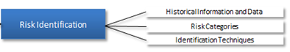

1. **Learning Objectives**

* Describe the risk identification process
* Demonstrate the use of several risk identification techniques
* Explain how to categorize risks
* Describe a basic Risk Register

1. **Content**

* Risk Identification Techniques
* Risk Categorization
* Risk Breakdown Structure
* Risk Register

1. **Step by Step**
2. Study the following:

Textbook

Chapter 4: Risk Management Planning

Chapter 5: Risk Identification

PMBOK

Chapter 10, section 10.2

Chapter 11, section 11.2

1. Forum question:

How does your company, deal with the first two processes of Project Risk Management as stated in the PMBOK? Use the F1.pdf file as a general reference for your discussion (you don’t have to complete the Risk Register shown.) Think of the sources of information, methods, etc., needed to complete a Risk Register.

1. **Lesson summary**

This module focuses on risk identification, a systematic identification and classification process of risks. In this process, all the potential risks that could affect the project’s objectives are identified and categorized. A complete enumeration of risks can only be achieved when risk identification addresses different aspects of the project in terms of various risk’s causes. Company can rely on previous projects to identify these causes, potential risks and effects.

There are several sources of risks that can be used to identify risk’s causes and can be used as a categorization scheme. A hierarchical risk breakdown structure (RBS) system may help development of a common language about risks and easy retrieval of similar risk sources when needed. Therefore, in this module, you’ll have the opportunity to study risk identification procedures, risk categorization and how these concepts fit in the risk management planning.

1. **Self-assessment**

There will be a multiple choice and true-and-false (13 questions) quiz.

**Week 3**

1. **Main Topic**

Risk analysis examines each identified risk issue, refines the portrayal of the risk and assesses the associated impact inherent in a project. Its main objective is to assess the probability and impact of risks. The first part of the analysis process is known as qualitative risk analysis, and it is here that a probability/impact risk rating matrix is developed or revised. This is an important step because it helps reduce the number of risks previously identified. Some will be more important than others, requiring more resources to mitigate them. Others will be ‘let-to-be.’ In consequence, during this step the project team can begin to get a feel for those issues that will have the greatest impact on the project’s objectives, and how to plan for potential responses. At the end of this process the project team will have a list of prioritized risks and a list of risks that needs further investigation through qualitative risk analysis and an enhance Risk Register.

Overall, it appears that organizations that manage their projects more efficiently and more effectively tend to attach more value to risk analysis tools. Other than establishing risk probability and impact, most managers recognize the benefits of using qualitative techniques to get a first look (and sometimes, a last look) at the causes of a risk. One problem with qualitative techniques is that they could to be too simplistic to capture the subtlety of risky situations. In these cases, quantitative techniques based on probabilistic measures are needed if the underline nature or impact of a risk is not well understood.

Quantitative risk analysis techniques include expert interviews, expected monetary value, and response matrices along with more advanced risk techniques such as the Monte-Carlo method. Other popular techniques are sensitivity analysis and decision tree (Bayesian) analysis. Lately, risk analysis and management have attracted a lot of attention in the literature with more coverage on quantitative methods of analysis. There has been a proliferation of software that performs quantitative risk analysis, which uses sophisticated probabilistic methods to quantify uncertainty.

1. **Conceptual Map**

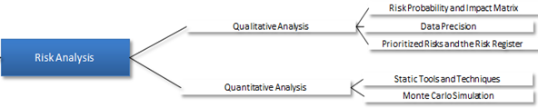

1. **Learning Objectives**

* Describe how to build an Impact/Probability matrix.
* Demonstrate how to prioritize risks
* List various qualitative and quantitative risk analysis techniques
* Explain how to update the Risk Register

1. **Content**

* Qualitative risk analysis
* Risk impact/probability matrix
* Quantitative risk analysis
* Risk Register

1. **Step by Step**

Study the following chapters of the Textbook

Chapter 6: Qualitative Risk Analysis

Chapter 7: Quantitative Risk Analysis

PMBOK

Chapter 11, section 11.3 & 10.4

1. **Lesson summary**

This module analyzed the fundamentals of risk analysis. It began by discussing qualitative risk analysis. Several suggestions on developing or revising Probability/Impact risk rating matrices were provided. Rating systems (scales) were discussed, and an initial definition of risk rating (probability×impact) provided. Specific qualitative techniques were discussed.

This module emphasized that quantitative risk analysis procedures are predominantly used when the underlying nature of the cause or effect of a risk is not well understood. With the results of this step, the project team can better judge the allocation of resources in the risk response process and enhance the Risk Register.

1. **Self-assessment**

There will be a multiple choice and true-and-false (13 questions) quiz.

**Week 4**

1. **Main Topic**

In the risk response process, potential strategies are identified, evaluated and selected in order to increase the likelihood of occurrence of positive risk events and/or decrease the likelihood of occurrence of negative risk events, both to an acceptable level. In practice, the choice of a specific risk-handling-strategy is contingent on the risk situation and the project distinctiveness. PMI describes generic categories for responding to project risks, depending on the nature of the risk: threat or opportunity. For the former, widely accepted generic strategies are avoidance, transference, mitigate and acceptance. Within these high-level options, specific responses can be formulated according to the circumstances of the project, the threat, the cost of the response and the resources required for the response. On the flip side, risk response also includes generic strategies that increase the probability of materializing an opportunity (i.e., exploiting, share, enhance and accept). In choosing the response strategies it is critically important to consider the feasibility of selected response measures and the time available for them. In the event that a risk response strategy has been deployed and flopped, the project team should have a fallback (backup) plan.

Identify risks that weren’t identified during the identification process, considered insignificant, or that arises as a direct result of implementing a specific response strategy, should be accounted for. In most projects, these situations are taken care on allocating appropriate contingency reserve. Consequently, it is imperative to realize that response strategies don’t always work as expected (once the project is being implemented, many new situations could surface), and even a backup plan might fail. Depending of the importance of the project or the risk, the project team has to take decide on the appropriate hierarchy of response plans for each risk. Once more, the Risk Register has to be revised after this process.

1. **Mind Map**

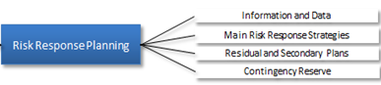

1. **Learning Objectives**

* Understand the information and data needed in the development of a risk response strategy
* Describe the generic risk response strategies
* Understand the concepts of a fallback plan, risk residuals and contingency reserve

1. **Content**

* Generic risk response strategies
* Fallback plans
* Secondary plans
* Consequence on the contingency reserve

1. **Step by Step**

Study the following:

Textbook

Chapter 8: Response Planning

PMBOK

Chapter 10, section 10.3

Chapter 11, section 11.5

Forum question:

The generic response strategies in the PMBOK are only a categorization of actual action plans that - companies could use in responding to risks. Please read the following example.

“A project manager is working in a project whose main objective is to build a medical device for people that live in extremely cold environments. After the prototype has been designed, the following step requires some testing. Testing is very important because (1) it is mandatory and (2) it will demonstrate the trustworthiness of the device. The test must be done in extreme weather conditions that could be detrimental in collecting data. It is the first time the medical device will be used under those conditions. In this case, the project manager decided to use the generic risk response strategy “Mitigation”, to make sure that the test was conducted properly.”

What does the project manager mean when he said he would like to use a Mitigation strategy? If instead of “Mitigation” the project manager decides to “Transfer” the risk, what do you think he/she meant? (Please, in your answer, give specific action plans.)

1. **Lesson summary**

This module analyzed the risk response planning process. It was important to have all of the information gathered in prior process and from other areas of knowledge (as defined in the PMBOK, 5th edition) at the beginning of the process. The main focus of the module is understanding the generic risk response strategies for risks (threats or opportunities). Several suggestions on specific actions are provided. Finally, there is a discussion on the necessity of “backup strategies” and the need to revise the contingency reserve.

1. **Self-assessment**

There will be a multiple choice and true-and-false (13 questions) quiz.

**Week 5**

1. **Main Topic**

Risk monitoring and control is an iterative and continuous set of processes to ensure that current risks are being properly mitigated throughout the projects life. It involves various activities such as risk tracking, risk response tracking, technical performance measurement, monitoring of residual, new risks that could present themselves after an action, and the execution of the action plan and evaluation of its deployment. During the execution of this process, a reassessment of risks or re-examining risk response measures can take place.

One of the most used methods for monitoring overall project performance against a plan baseline is earned value analysis (EVA). In general terms, it is a quantitative approach used in the evaluation of the project’s overall performance based on cost and schedule deviations. Any risk effect will be reflected on the EVA.

Key actions in this step are workaround plans, corrective actions, project change requests, update of the risk response plan, risk database and updates to the risk identification checklist. In this phase risk response decisions should be in place for pre-established milestones and performance indicators. During the implementation of this process, all project communication activities are necessary to be in place and operational.

1. **Mind Map**

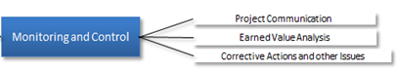

1. **Learning Objectives**

* Understand the importance of project communication in monitoring and control of risks
* Describe the earned value analysis in the context of risk management
  + Explain how to conduct corrective actions and other matters during the monitoring and control of risks

1. **Content**

* Monitoring and control mechanisms
* Corrective actions and risk register adjustments
* Earned value analysis

1. **Step by Step**

Study the following,

Textbook

Chapter 9: Risk Monitoring and Control

Chapter 10: Risk Communication and Documentation

PMBOK

Chapter 10, section 10.2

Chapter 11, section 11.6

1. **Lesson summary**

**Project monitoring and control is closely tied to project execution; and it is the only process that is executed during the implementation of the project. It is during this phase that work progress is measured against a project’s objectives to ensure the project stays within the determined boundaries. The objective is to continuously monitor project risks and control the change from the project baseline.**

This module discusses various aspects of the process. Some issues that are frequently monitored at this stage are the status of those risks that haven’t been triggered, strategy responses’ effectiveness, monitoring residual risks, and the status of the contingency reserve. Most issues are a contrast against agreed time, cost and performances’ criteria. In the process, any deviation from the established plan has to be accounted for and adjusted accordingly. Earned value analysis is used as a scorecard at a conjoined level. Good practices of this process provide information that assists with making an effective decision in advance of any risk occurring.

1. **Self-assessment**

* There will be a multiple choice and true-and-false (13 questions) quiz.
* Each student must take and pass a comprehensive test consisting of 50 multiple choice and true-and-false questions (minimum passing grade is 70 percent.)