**Green Project Management EnVex 2.1**

**“Requirements and Constraints”**

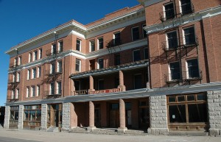Ernie Banks Esq.   
1060 West Addison Street  
Chicago, IL 60613  
(773) 404-2827

**MEMORANDUM**

**RE: Issue of Letter dated 22 Oct 11**

After a few days to consider the letter we sent with regards to the sad loss of your family member, we are writing to understand what your intentions are with regards to the property.

If you are happy to take on the project that has been requested by the late Milton P Reiker then we would like you to come in and visit us.

To determine that you fully appreciate the whole concept of the project and before we would feel comfortable releasing the first stage funding from his will, we would like to determine that you understand the scale of the work involved and that you appreciate the sheer size of this inheritance. Until we are the holders of the estate are satisfied that you show full understanding then we will not pursue the transfer of the asset nor the funding.

To assist us with this task we ask that you provide an outline plan of what you feel the best approach would be and then identify from this approach, giving your reasons for this approach and both the benefits and the risks of your chosen delivery method.

Finally, although at an early stage, could you outline how you would make this renovation meets the needs of your late family member with regards to his wishes of a greener, cleaner hotel.

This project will attract much attention and so it is essential we feel the confidence in what and how you will do this work, before we approve your bequest.

The original letter we sent is attached and the additional internal photos of the internal aspects of the hotel that you requested are included.

Regards,



Ernie Banks Esq.  
1060 West Addison Street  
Chicago, IL 60613  
(773) 404-2827

22 Oct 11

Dear ___________________

On behalf of the Trustees and Executor of the estate of the late Milton P. Reiker, I wish to notify you that the late Mr. Reiker made you a beneficiary to his WILL.   
  
He left the Windy Hotel located at 10435 W. Michigan Ave, in Downtown Chicago. The hotel closed its doors in 1978 and due to its historical landmark standing has remained in its current state.

In addition to the hotel, the sum of 15 Million, One Hundred Thousand Dollars (USD $15,100.000.00) has been left to you in an escrow account with the stipulation that it be used to restore the hotel to its former glory while incorporating a green building approach and ultimately become the only LEED certified hotel in downtown Chicago.

Being a widely travelled man, Milton had little contact with his family and in his final years became a large proponent of sustainable development, becoming extremely successful in his endeavors and had hoped to make this hotel has final effort before retiring. He left it to you as he felt that you were the only one in the family who could successfully make his dream a reality.

I await your prompt response.

Yours in Service,



Ernie Banks Esquire

You have 60 minutes to deliver the requirements and then 30 minutes to present and hold a questions and answers session.

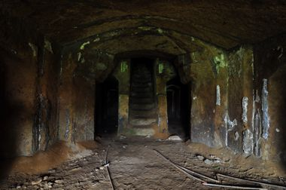 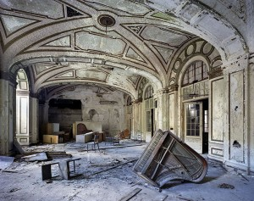

Figure 1 – Ballroom Figure 2 - Original Dining Hall

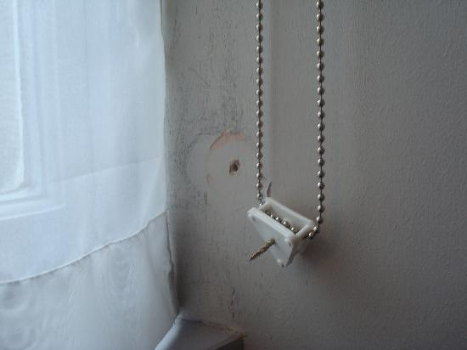 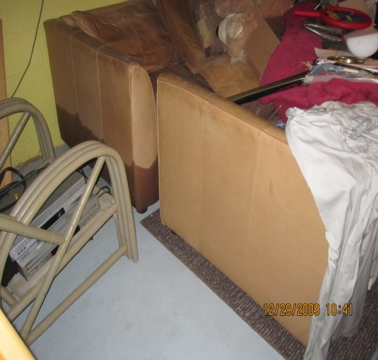

Figure 3 – Furnishings Figure 4 - Bathroom Fittings

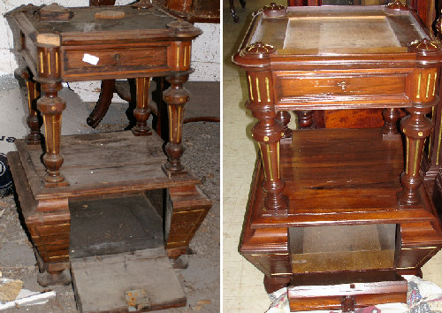 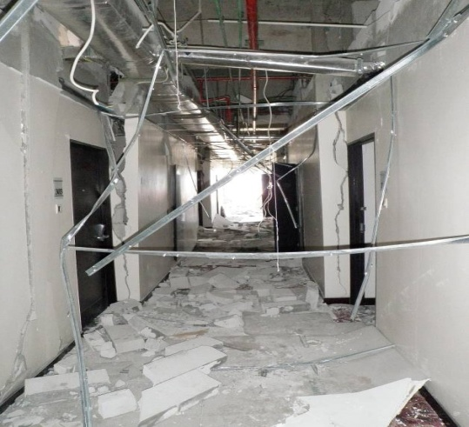

Figure 5 - Corridors and Reception View Figure 6 - Side Tables Current and Original View