**Green Project Management EnVex 2.2**



“**Small Steps”**

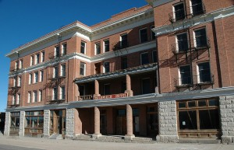Ernie Banks Esq.   
1060 West Addison Street  
Chicago, IL 60613  
(773) 404-2827

**MEMORANDUM**

**RE: Confirmation of Acceptance**

We are pleased to announce that after the meeting and due consideration, Ernie Banks Esq. is happy with your proposal and is ready to release the property and the first stage of funding to you.

What we were particularly impressed by was the way you have decided to stage the work, this was highly innovative and will mean that you retain greater control of the project than other approaches may have done.

As first appearance is everything, we believe that your first stage, as discussed in our meeting should be the lobby and reception area. To help us release the right level of funding for this section of the work, please would you assist us by identifying the appropriate parties that will be making up this but also future stages of the project.

We have found in the past, that this can best be carried out by mapping the relevant parties through a grid or table system to best understand why they are involved, what their interest or impact on the project will be and then also how they will be managed through the whole project.

As we said, the funding is now ready for your release but this will determine the level of funding needed to allow you to control your costs at this key time.

The complete duration as we know will be four months for this first stage, so how is this stage actually proportioned?

Please provide the outline times for this first stage, working on subjective or comparative estimates as I accept accuracy at this early phase may be a little difficult. Be as realistic with your values as possible covering all costs you feel appropriate.

We await the two documents from you at your earliest convenience.

Regards,



Ernie Banks Esq.  
1060 West Addison Street  
Chicago, IL 60613  
(773) 404-2827

22 Oct 11

Dear ___________________

On behalf of the Trustees and Executor of the estate of the late Milton P. Reiker, I wish to notify you that the late Mr. Reiker made you a beneficiary to his WILL.   
  
He left the Windy Hotel located at 10435 W. Michigan Ave, in Downtown Chicago. The hotel closed its doors in 1978 and due to its historical landmark standing has remained in its current state.

In addition to the hotel, the sum of 7 Million, One Hundred Thousand Dollars (USD $7,100.000.00) has been left to you in an escrow account with the stipulation that it be used to restore the hotel to its former glory while incorporating a green building approach and ultimately become the only LEED certified hotel in downtown Chicago.

Being a widely travelled man, Milton had little contact with his family and in his final years became a large proponent of sustainable development, becoming extremely successful in his endeavors and had hoped to make this hotel has final effort before retiring. He left it to you as he felt that you were the only one in the family who could successfully make his dream a reality.

I await your prompt response.

Yours in Service,



Ernie Banks Esquire

You have 90 minutes to deliver the requirements and then 30 minutes to present and hold a questions and answers session.

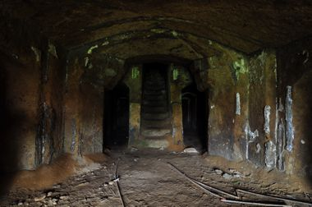 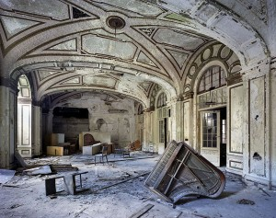

Figure 1 – Ballroom Figure 2 - Original Dining Hall

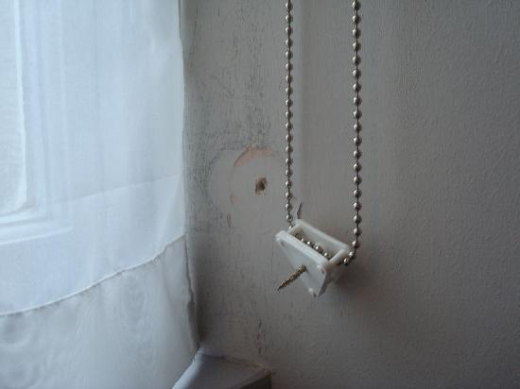 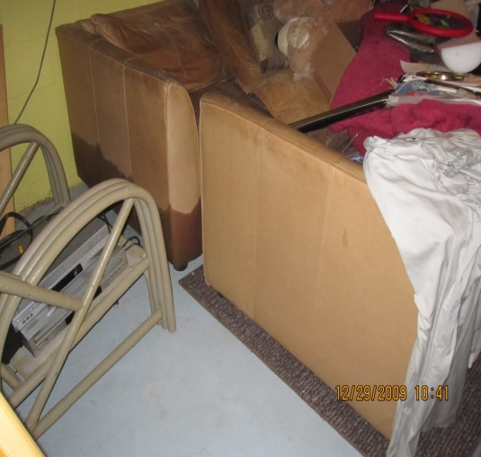

Figure 3 – Furnishings Figure 4 - Bathroom Fittings

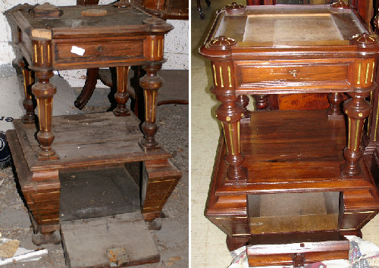 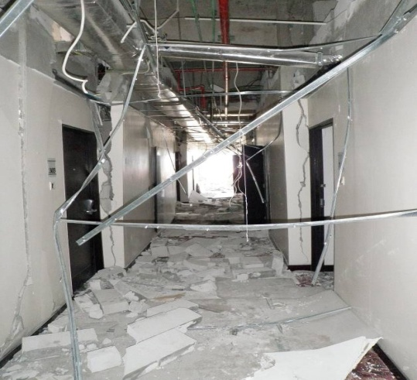

Figure 5 - Corridors and Reception View Figure 6 - Side Tables Current and Original View