**Green Project Management EnVex 2.3**

**“Getting into the Detail”**

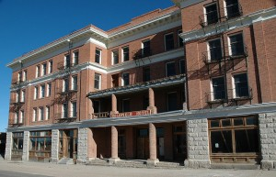Ernie Banks Esq.   
1060 West Addison Street  
Chicago, IL 60613  
(773) 404-2827

**MEMORANDUM**

**RE: Stage One Success**

Thank you for your letter you provided us to inform us that the first stage has gone so very well for you. I was pleased to hear that your estimates went so well for such a short session.

Using the knowledge you are gaining from each step of the project is very valuable as learning as you work will allow you to continuously improve the project. With that in mind you are reaching a key part of the project where detail is the key part.

You have another five floors to complete, including the ballroom and main dining room which you have already seen the poor condition of. What we are looking for from you now to release the funding, is an understanding of which contractors you will use and why you have selected them. We have helped you a little by releasing to you a list of all valid suppliers that state they are green and use green methods, however you still need to decide on how green your hotel will be and what legacy you will leave behind for your late family member.

You will need to review the attachments and decide what green aspects you are going to have to your project and to your hotel. What we are looking for from you is a breakdown of the costs, for each floor. They are all the same size in floor space but keep in mind the sixth floor has always been the penthouse and the main dining room and ballroom are on the third floor. There are two bars; third floor and fifth floor, the remainder of the hotel to be repaired are rooms.

So far you have spent $757, 845 of the investment.

Prepare your documents for our review floor by floor and give details of what aspects of the building you are prosing to make greener, using as a base, your answers in the first exercise.

Regards,



Ernie Banks Esq.  
1060 West Addison Street  
Chicago, IL 60613  
(773) 404-2827

22 Oct 11

Dear ___________________

On behalf of the Trustees and Executor of the estate of the late Milton P. Reiker, I wish to notify you that the late Mr. Reiker made you a beneficiary to his WILL.   
  
He left the Windy Hotel located at 10435 W. Michigan Ave, in Downtown Chicago. The hotel closed its doors in 1978 and due to its historical landmark standing has remained in its current state.

In addition to the hotel, the sum of 7 Million, One Hundred Thousand Dollars (USD $7,100.000.00) has been left to you in an escrow account with the stipulation that it be used to restore the hotel to its former glory while incorporating a green building approach and ultimately become the only LEED certified hotel in downtown Chicago.

Being a widely travelled man, Milton had little contact with his family and in his final years became a large proponent of sustainable development, becoming extremely successful in his endeavors and had hoped to make this hotel has final effort before retiring. He left it to you as he felt that you were the only one in the family who could successfully make his dream a reality.

I await your prompt response.

Yours in Service,



Ernie Banks Esquire

You have 120 minutes to deliver the requirements and then 30 minutes to present and hold a questions and answers session.

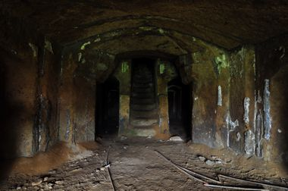 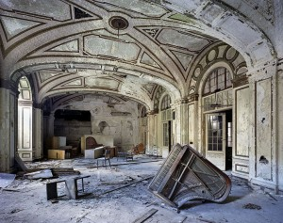

Figure 1 – Ballroom Figure 2 - Original Dining Hall

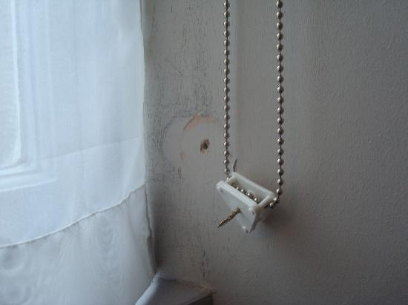 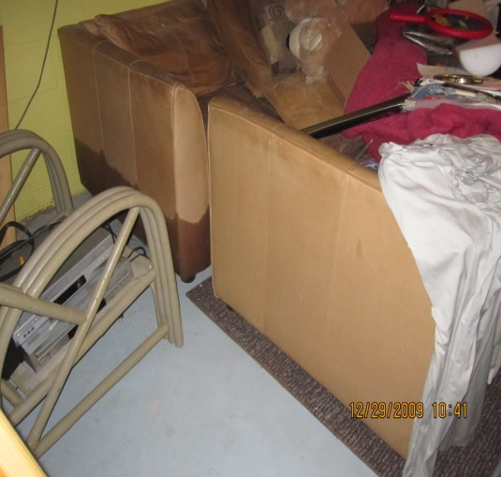

Figure 3 – Furnishings Figure 4 - Bathroom Fittings

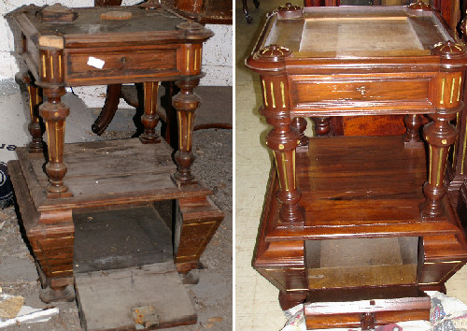 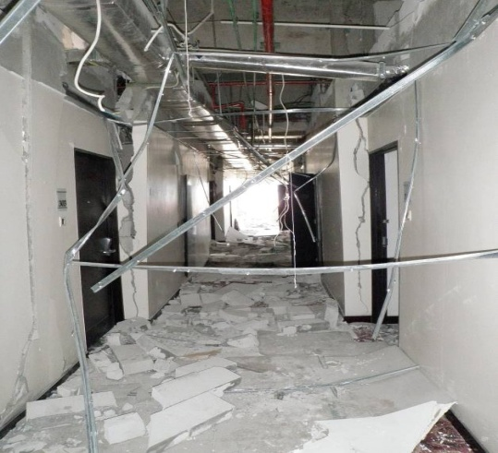

Figure 5 - Corridors and Reception View Figure 6 - Side Tables Current and Original View

**Report of Available Suppliers**

|  |  |  |
| --- | --- | --- |
| **Product ID** | **Name** | **Unit Cost** |
| Door, Entry Phone, Single | Get It Done Limited | $ 1,700.00 |
| Door, Remote Control, Pack | Get It Done Limited | $ 670.00 |
| Door, Remote Control, Pack | Cheap and Cheerful | $ 890.00 |
| Handrail, Special Needs, Pack | Reliable Company Limited | $ 40.00 |
| Handrail, Special Needs, Pack | Cheap and Cheerful | $ 70.00 |
| Handrail, Special Needs, Pack | Wattle and Daub | $ 60.00 |
| Handrail, Special Needs, Pack | Bent Builders | $ 50.00 |
| Paving, Special Needs, Pack | Reliable Company Limited | $ 1,000.00 |
| Paving, Special Needs, Pack | Cheap and Cheerful | $ 1,020.00 |
| Paving, Special Needs, Pack | Wattle and Daub | $ 1,050.00 |
| Paving, Special Needs, Pack | Bent Builders | $ 1,100.00 |
| Ramp, Special Needs | Reliable Company Limited | $ 5,000.00 |
| Ramp, Special Needs | Cheap and Cheerful | $ 5,000.00 |
| Ramp, Special Needs | Wattle and Daub | $ 4,500.00 |
| Ramp, Special Needs | Bent Builders | $ 5,000.00 |
| Communications, Intruder Alarm, Pack | Reliable Company Limited | $ 2,130.00 |
| Communications, Wi-Fi, Pack | Get It Done Limited | $ 4,230.00 |
| Artist Impression | Reliable Company Limited | $ 5,000.00 |
| Brick, Foundation, Pack | Reliable Company Limited | $16,000.00 |
| Brick, Foundation, Pack | Cheap and Cheerful | $13,000.00 |
| Brick, Foundation, Pack | Wattle and Daub | $17,000.00 |
| Brick, Foundation, Pack | Bent Builders | $16,000.00 |
| Damp Proof Course, Pack | Cheap and Cheerful | $ 900.00 |
| Damp Proof Course, Pack | Wattle and Daub | $ 1,000.00 |
| Damp Proof Course, Pack | Bent Builders | $ 600.00 |
| Damp Proof Course, Pack | Reliable Company Limited | $ 1,100.00 |
| Brick, Ground Floor, Pack | Reliable Company Limited | $56,000.00 |
| Brick, Ground Floor, Pack | Cheap and Cheerful | $46,000.00 |
| Brick, Ground Floor, Pack | Wattle and Daub | $56,000.00 |
| Brick, Ground Floor, Pack | Bent Builders | $40,000.00 |
| Door, Front | Reliable Company Limited | $ 1,650.00 |
| Door, Front, Double Width (Ballroom) | Reliable Company Limited | $ 3,000.00 |
| Door, Front | Cheap and Cheerful | $ 1,350.00 |
| Door, Front | Wattle and Daub | $ 1,850.00 |
| Door, Front | Bent Builders | $ 1,350.00 |
| Window, Shuttered, Dual Casement | Reliable Company Limited | $ 3,500.00 |
| Window, Shuttered, Dual Casement | Cheap and Cheerful | $ 2,850.00 |
| Window, Shuttered, Dual Casement | Wattle and Daub | $ 3,500.00 |
| Window, Shuttered, Dual Casement | Bent Builders | $ 2,850.00 |
| Window, Small Glazed | Reliable Company Limited | $ 650.00 |
| Window, Small Glazed | Cheap and Cheerful | $ 500.00 |
| Window, Small Glazed | Wattle and Daub | $ 650.00 |
| Window, Small Glazed | Bent Builders | $ 500.00 |
| Brick, First Floor, Pack | Reliable Company Limited | $59,000.00 |
| Brick, First Floor, Pack | Cheap and Cheerful | $49,000.00 |
| Brick, First Floor, Pack | Wattle and Daub | $59,000.00 |
| Brick, First Floor, Pack | Bent Builders | $48,000.00 |
| Window, Dual Casement | Reliable Company Limited | $ 2,500.00 |
| Window, Dual Casement | Cheap and Cheerful | $ 2,000.00 |
| Window, Dual Casement | Wattle and Daub | $ 2,500.00 |
| Window, Dual Casement | Bent Builders | $ 2,000.00 |
| Window, Shuttered | Reliable Company Limited | $ 3,500.00 |
| Window, Shuttered | Cheap and Cheerful | $ 2,850.00 |
| Window, Shuttered | Wattle and Daub | $ 3,500.00 |
| Window, Shuttered | Bent Builders | $ 2,850.00 |
| Brick, Parapet | Reliable Company Limited | $12,000.00 |
| Brick, Parapet | Cheap and Cheerful | $13,500.00 |
| Brick, Parapet | Wattle and Daub | $11,000.00 |
| Brick, Parapet | Bent Builders | $12,000.00 |
| Tile, Roof, Pack | Reliable Company Limited | $62,000.00 |
| Tile, Roof, Pack | Cheap and Cheerful | $62,500.00 |
| Tile, Roof, Pack | Wattle and Daub | $59,800.00 |
| Tile, Roof, Pack | Bent Builders | $61,000.00 |
| Skylight | Reliable Company Limited | $ 3,400.00 |
| Skylight | Cheap and Cheerful | $ 2,800.00 |
| Skylight | Wattle and Daub | $ 3,800.00 |
| Skylight | Bent Builders | $ 2,800.00 |
| Chimney, Roof, Single | Reliable Company Limited | $ 5,000.00 |
| Chimney, Roof, Single | Cheap and Cheerful | $ 5,600.00 |
| Chimney, Roof, Single | Wattle and Daub | $ 5,800.00 |
| Chimney, Roof, Single | Bent Builders | $ 5,200.00 |
| Brick, External Stairs, Pack | Reliable Company Limited | $ 1,400.00 |
| Brick, External Stairs, Pack | Cheap and Cheerful | $ 1,800.00 |
| Brick, External Stairs, Pack | Wattle and Daub | $ 1,400.00 |
| Brick, External Stairs, Pack | Bent Builders | $ 1,800.00 |
| Door, Back, Single | Reliable Company Limited | $ 400.00 |
| Door, Back, Single | Cheap and Cheerful | $ 900.00 |
| Door, Back, Single | Wattle and Daub | $ 400.00 |
| Door, Back, Single | Bent Builders | $ 900.00 |
| External Landscaping, Pack | Reliable Company Limited | $ 2,500.00 |
| External Landscaping, Pack | Cheap and Cheerful | $ 2,550.00 |
| External Landscaping, Pack | Wattle and Daub | $ 2,200.00 |
| External Landscaping, Pack | Bent Builders | $ 1,980.00 |
| Fencing, External Landscaping, Pack | Reliable Company Limited | $ 100.00 |
| Fencing, External Landscaping, Pack | Cheap and Cheerful | $ 100.00 |
| Fencing, External Landscaping, Pack | Wattle and Daub | $ 80.00 |
| Fencing, External Landscaping, Pack | Bent Builders | $ 90.00 |
| Platform, External Stairs, Single | Wattle and Daub | $ 800.00 |
| Verandah, First Floor, Pack | Bent Builders | $ 8,670.00 |
| Window, Kitchen, Single | Reliable Company Limited | $ 2,500.00 |
| Window, Kitchen, Single | Cheap and Cheerful | $ 2,000.00 |
| Window, Kitchen, Single | Wattle and Daub | $ 2,500.00 |
| Window, Kitchen, Single | Bent Builders | $ 2,000.00 |
| Window, Single Casement | Reliable Company Limited | $ 2,500.00 |
| Window, Single Casement | Cheap and Cheerful | $ 2,000.00 |
| Window, Single Casement | Wattle and Daub | $ 2,500.00 |
| Window, Single Casement | Bent Builders | $ 2,000.00 |
| Insurance, Level 1 | Reliable Company Limited | $ 300.00 |
| Insurance, Level 1 | Cheap and Cheerful | $ 320.00 |
| Insurance, Level 2 | Reliable Company Limited | $ 350.00 |
| Insurance, Level 2 | Cheap and Cheerful | $ 350.00 |
| Insurance, Level 3 | Reliable Company Limited | $ 380.00 |
| Insurance, Level 3 | Cheap and Cheerful | $ 360.00 |
| Insurance, Level 4 | Reliable Company Limited | $ 450.00 |
| Insurance, Level 4 | Cheap and Cheerful | $ 420.00 |
| Generator, Diesel | Reliable Company Limited | $ 120.00 |
| Generator, Diesel | Cheap and Cheerful | $ 120.00 |
| Generator, Diesel | Wattle and Daub | $ 120.00 |
| Generator, Diesel | Get It Done Limited | $ 120.00 |
| Generator, Manual | Get It Done Limited | $ 30.00 |
| Generator, Petrol | Reliable Company Limited | $ 50.00 |
| Generator, Petrol | Bent Builders | $ 70.00 |
| Generator, Petrol | Get It Done Limited | $ 60.00 |
| Panel, Solar Power | Get It Done Limited | $ 8,000.00 |
| Pump, Air | Reliable Company Limited | $ 10.00 |
| Pump, Air | Cheap and Cheerful | $ 10.00 |
| Pump, Air | Wattle and Daub | $ 10.00 |
| Pump, Air | Bent Builders | $ 10.00 |
| Pump, Water | Reliable Company Limited | $ 40.00 |
| Pump, Water | Cheap and Cheerful | $ 40.00 |
| Pump, Water | Wattle and Daub | $ 40.00 |
| Pump, Water | Bent Builders | $ 40.00 |
| Scaffolding | Brown and Gold Scaffolding | $ 1,200.00 |
| Tarpaulin | Reliable Company Limited | $ 650.00 |
| Tarpaulin rental | #N/A | $ 50.00 |
| Tarpaulin rental | Get It Done Limited | $ 50.00 |
| Television | Get It Done Limited | $ 8,990.00 |
| Television Rental | Get It Done Limited | $ 200.00 |
| Sandbags | Get It Done Limited | $ 10.00 |
| Decorator | Reliable Company Limited | $ 1,300.00 |
| Decorator | Cheap and Cheerful | $ 1,300.00 |
| Decorator | Wattle and Daub | $ 1,300.00 |
| Decorator | Bent Builders | $ 1,300.00 |
| Electrician | Reliable Company Limited | $ 1,300.00 |
| Electrician | Cheap and Cheerful | $ 1,300.00 |
| Electrician | Wattle and Daub | $ 1,300.00 |
| Electrician | Bent Builders | $ 1,300.00 |
| Plumber | Reliable Company Limited | $ 1,300.00 |
| Plumber | Cheap and Cheerful | $ 1,300.00 |
| Plumber | Wattle and Daub | $ 1,300.00 |
| Plumber | Bent Builders | $ 1,300.00 |
| Roofer | Reliable Company Limited | $ 2,400.00 |
| Roofer | Cheap and Cheerful | $ 2,400.00 |
| Roofer | Wattle and Daub | $ 2,400.00 |
| Roofer | Bent Builders | $ 2,400.00 |
| Catering, Mobile | Get It Done Limited | $ 120.00 |
| Equipment, Safety | Reliable Company Limited | $ 200.00 |
| Equipment, Safety | Cheap and Cheerful | $ 220.00 |
| Equipment, Safety | Get It Done Limited | $ 250.00 |
| Equipment, Safety | Get It Done Limited | $ 200.00 |
| Fencing, Site | Cheap and Cheerful | $ 50.00 |
| Fencing, Site | Reliable Company Limited | $ 60.00 |
| Fencing, Site | Cheap and Cheerful | $ 90.00 |
| Fencing, Site | Wattle and Daub | $ 80.00 |
| Security - Level 1 | Bent Builders | $ 200.00 |
| Site Agent | Reliable Company Limited | $ 1,200.00 |
| Site Services | Cheap and Cheerful | $ 1,000.00 |
| Creche | Wattle and Daub | $ 50.00 |
| Overheads | Bent Builders | $ 1,250.00 |
| Overheads | Reliable Company Limited | $ 1,000.00 |
| Overheads | Cheap and Cheerful | $ 600.00 |
| Catering, Opening Party | Wattle and Daub | $ 50.00 |
| Catering, Closing Celebration | Bent Builders | $ 200.00 |
| Training, Fire Safety | Reliable Company Limited | $ 600.00 |
| Training, General Safety | Get It Done Limited | $ 600.00 |
| Training, Manual Handling | Reliable Company Limited | $ 500.00 |
| Training, Materials Handling | Reliable Company Limited | $ 300.00 |
| Training, Aerobics | Cheap and Cheerful | $ 500.00 |
| Vehicle, JCB | Wattle and Daub | $ 800.00 |
| Vehicle, JCB | Bent Builders | $ 900.00 |
| Vehicle, JCB | Cheap and Cheerful | $ 1,100.00 |
| Vehicle, JCB | Wattle and Daub | $ 1,050.00 |
| Crane, Wheeled | Bent Builders | $ 500.00 |
| Crane, Wheeled | Reliable Company Limited | $ 450.00 |
| Crane, Wheeled | Reliable Company Limited | $ 300.00 |
| Vehicle, Truck (40 unit) | Cheap and Cheerful | $ 800.00 |
| Vehicle, Truck (8 unit) | Wattle and Daub | $ 400.00 |
| Vehicle, Truck (4 unit) | Bent Builders | $ 300.00 |
| Crane, Heavy Lift | Reliable Company Limited | $ 800.00 |

All other materials or items are set at a similar price to those shown, however the eco-friendly versions of the materials are 15% more expensive.