**Green Project Management En Vex 2.4**



**“Learning for the Future”**

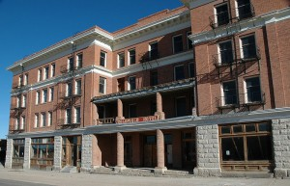Ernie Banks Esq.   
1060 West Addison Street  
Chicago, IL 60613  
(773) 404-2827

**MEMORANDUM**

**RE: Lessons Learned**

The importance of projects and of project management is that we are continuously looking to improve the work that we do and more importantly, how we do it.

After completing the exercises within the project Case Study over the last two days, we are very interested in what your team has learned from the exercises and how you might apply these skills and lessons in the future.

To that end, you are being tasked with the original project again, much as you could be in real life in the future. However, on this occasion we would like to see your approach to the first three exercises, taking into account the lessons that you have learned from each of the exercises throughout the course and from the advice of the instructor to appraise the project fully and also to take into account the change and green potentials to make as robust a project foundation as possible.

Finally, present this new version to the group in the form of a comparison to the original response you gave and explain why you have changed your approach and what benefits this improved approach would give.

I look forward to your response.

The full version of all the documentation you have used over the two days is attached below.

Regards,



Ernie Banks Esq.  
1060 West Addison Street  
Chicago, IL 60613  
(773) 404-2827

22 Oct 11

Dear ___________________

On behalf of the Trustees and Executor of the estate of the late Milton P. Reiker, I wish to notify you that the late Mr. Reiker made you a beneficiary to his WILL.   
  
He left the Windy Hotel located at 10435 W. Michigan Ave, in Downtown Chicago. The hotel closed its doors in 1978 and due to its historical landmark standing has remained in its current state.

In addition to the hotel, the sum of 7 Million, One Hundred Thousand Dollars (USD $7,100.000.00) has been left to you in an escrow account with the stipulation that it be used to restore the hotel to its former glory while incorporating a green building approach and ultimately become the only LEED certified hotel in downtown Chicago.

Being a widely travelled man, Milton had little contact with his family and in his final years became a large proponent of sustainable development, becoming extremely successful in his endeavors and had hoped to make this hotel has final effort before retiring. He left it to you as he felt that you were the only one in the family who could successfully make his dream a reality.

I await your prompt response.

Yours in Service,



Ernie Banks Esquire

You have 60 minutes to deliver the requirements and then 30 minutes to present and hold a questions and answers session.

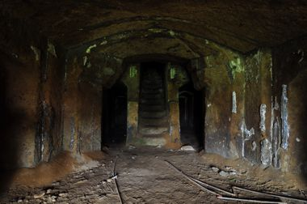 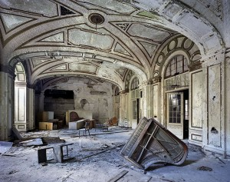

Figure 1 – Ballroom Figure 2 - Original Dining Hall

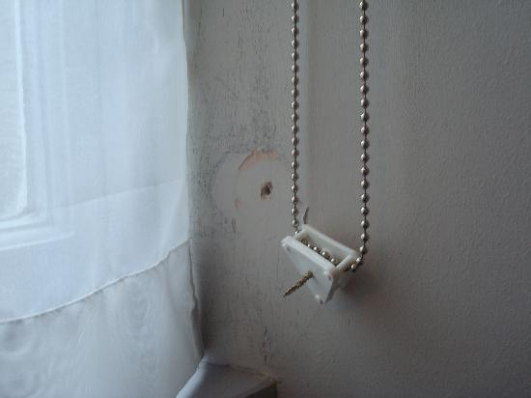 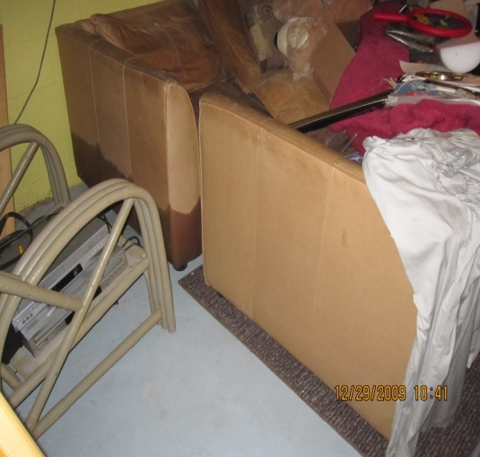

Figure 3 – Furnishings Figure 4 - Bathroom Fittings

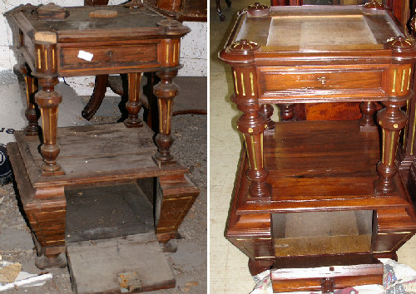 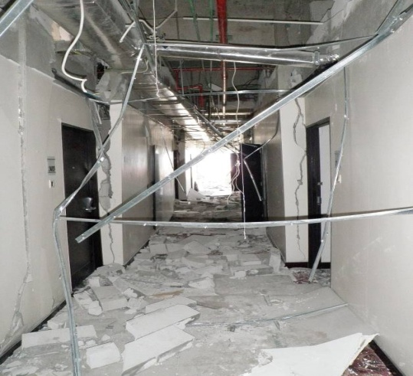

Figure 5 - Corridors and Reception View Figure 6 - Side Tables Current and Original View

**Report of Available Suppliers**

|  |  |  |
| --- | --- | --- |
| **Product ID** | **Name** | **Unit Cost** |
| Door, Entry Phone, Single | Get It Done Limited | $ 1,700.00 |
| Door, Remote Control, Pack | Get It Done Limited | $ 670.00 |
| Door, Remote Control, Pack | Cheap and Cheerful | $ 890.00 |
| Handrail, Special Needs, Pack | Reliable Company Limited | $ 40.00 |
| Handrail, Special Needs, Pack | Cheap and Cheerful | $ 70.00 |
| Handrail, Special Needs, Pack | Wattle and Daub | $ 60.00 |
| Handrail, Special Needs, Pack | Bent Builders | $ 50.00 |
| Paving, Special Needs, Pack | Reliable Company Limited | $ 1,000.00 |
| Paving, Special Needs, Pack | Cheap and Cheerful | $ 1,020.00 |
| Paving, Special Needs, Pack | Wattle and Daub | $ 1,050.00 |
| Paving, Special Needs, Pack | Bent Builders | $ 1,100.00 |
| Ramp, Special Needs | Reliable Company Limited | $ 5,000.00 |
| Ramp, Special Needs | Cheap and Cheerful | $ 5,000.00 |
| Ramp, Special Needs | Wattle and Daub | $ 4,500.00 |
| Ramp, Special Needs | Bent Builders | $ 5,000.00 |
| Communications, Intruder Alarm, Pack | Reliable Company Limited | $ 2,130.00 |
| Communications, Wi-Fi, Pack | Get It Done Limited | $ 4,230.00 |
| Artist Impression | Reliable Company Limited | $ 5,000.00 |
| Brick, Foundation, Pack | Reliable Company Limited | $16,000.00 |
| Brick, Foundation, Pack | Cheap and Cheerful | $13,000.00 |
| Brick, Foundation, Pack | Wattle and Daub | $17,000.00 |
| Brick, Foundation, Pack | Bent Builders | $16,000.00 |
| Damp Proof Course, Pack | Cheap and Cheerful | $ 900.00 |
| Damp Proof Course, Pack | Wattle and Daub | $ 1,000.00 |
| Damp Proof Course, Pack | Bent Builders | $ 600.00 |
| Damp Proof Course, Pack | Reliable Company Limited | $ 1,100.00 |
| Brick, Ground Floor, Pack | Reliable Company Limited | $56,000.00 |
| Brick, Ground Floor, Pack | Cheap and Cheerful | $46,000.00 |
| Brick, Ground Floor, Pack | Wattle and Daub | $56,000.00 |
| Brick, Ground Floor, Pack | Bent Builders | $40,000.00 |
| Door, Front | Reliable Company Limited | $ 1,650.00 |
| Door, Front | Cheap and Cheerful | $ 1,350.00 |
| Door, Front | Wattle and Daub | $ 1,850.00 |
| Door, Front | Bent Builders | $ 1,350.00 |
| Window, Shuttered, Dual Casement | Reliable Company Limited | $ 3,500.00 |
| Window, Shuttered, Dual Casement | Cheap and Cheerful | $ 2,850.00 |
| Window, Shuttered, Dual Casement | Wattle and Daub | $ 3,500.00 |
| Window, Shuttered, Dual Casement | Bent Builders | $ 2,850.00 |
| Window, Small Glazed | Reliable Company Limited | $ 650.00 |
| Window, Small Glazed | Cheap and Cheerful | $ 500.00 |
| Window, Small Glazed | Wattle and Daub | $ 650.00 |
| Window, Small Glazed | Bent Builders | $ 500.00 |
| Brick, First Floor, Pack | Reliable Company Limited | $59,000.00 |
| Brick, First Floor, Pack | Cheap and Cheerful | $49,000.00 |
| Brick, First Floor, Pack | Wattle and Daub | $59,000.00 |
| Brick, First Floor, Pack | Bent Builders | $48,000.00 |
| Window, Dual Casement | Reliable Company Limited | $ 2,500.00 |
| Window, Dual Casement | Cheap and Cheerful | $ 2,000.00 |
| Window, Dual Casement | Wattle and Daub | $ 2,500.00 |
| Window, Dual Casement | Bent Builders | $ 2,000.00 |
| Window, Shuttered | Reliable Company Limited | $ 3,500.00 |
| Window, Shuttered | Cheap and Cheerful | $ 2,850.00 |
| Window, Shuttered | Wattle and Daub | $ 3,500.00 |
| Window, Shuttered | Bent Builders | $ 2,850.00 |
| Water Piping | Reliable Company Limited | $12,000.00 |
| Water Piping | Cheap and Cheerful | $13,500.00 |
| Water Piping | Wattle and Daub | $11,000.00 |
| Water Piping | Bent Builders | $12,000.00 |
| Tile, Roof, Pack | Reliable Company Limited | $62,000.00 |
| Tile, Roof, Pack | Cheap and Cheerful | $62,500.00 |
| Tile, Roof, Pack | Wattle and Daub | $59,800.00 |
| Tile, Roof, Pack | Bent Builders | $61,000.00 |
| Skylight | Reliable Company Limited | $ 3,400.00 |
| Skylight | Cheap and Cheerful | $ 2,800.00 |
| Skylight | Wattle and Daub | $ 3,800.00 |
| Skylight | Bent Builders | $ 2,800.00 |
| Chimney, Roof, Single | Reliable Company Limited | $ 5,000.00 |
| Chimney, Roof, Single | Cheap and Cheerful | $ 5,600.00 |
| Chimney, Roof, Single | Wattle and Daub | $ 5,800.00 |
| Chimney, Roof, Single | Bent Builders | $ 5,200.00 |
| Brick, External Stairs, Pack | Reliable Company Limited | $ 1,400.00 |
| Brick, External Stairs, Pack | Cheap and Cheerful | $ 1,800.00 |
| Brick, External Stairs, Pack | Wattle and Daub | $ 1,400.00 |
| Brick, External Stairs, Pack | Bent Builders | $ 1,800.00 |
| Door, Back, Single | Reliable Company Limited | $ 400.00 |
| Door, Back, Single | Cheap and Cheerful | $ 900.00 |
| Door, Back, Single | Wattle and Daub | $ 400.00 |
| Door, Back, Single | Bent Builders | $ 900.00 |
| External Landscaping, Pack | Reliable Company Limited | $ 2,500.00 |
| External Landscaping, Pack | Cheap and Cheerful | $ 2,550.00 |
| External Landscaping, Pack | Wattle and Daub | $ 2,200.00 |
| External Landscaping, Pack | Bent Builders | $ 1,980.00 |
| Fencing, External Landscaping, Pack | Reliable Company Limited | $ 100.00 |
| Fencing, External Landscaping, Pack | Cheap and Cheerful | $ 100.00 |
| Fencing, External Landscaping, Pack | Wattle and Daub | $ 80.00 |
| Fencing, External Landscaping, Pack | Bent Builders | $ 90.00 |
| Platform, External Stairs, Single | Wattle and Daub | $ 800.00 |
| Verandah, First Floor, Pack | Bent Builders | $ 8,670.00 |
| Window, Kitchen, Single | Reliable Company Limited | $ 2,500.00 |
| Window, Kitchen, Single | Cheap and Cheerful | $ 2,000.00 |
| Window, Kitchen, Single | Wattle and Daub | $ 2,500.00 |
| Window, Kitchen, Single | Bent Builders | $ 2,000.00 |
| Window, Single Casement | Reliable Company Limited | $ 2,500.00 |
| Window, Single Casement | Cheap and Cheerful | $ 2,000.00 |
| Window, Single Casement | Wattle and Daub | $ 2,500.00 |
| Window, Single Casement | Bent Builders | $ 2,000.00 |
| Insurance, Level 1 | Reliable Company Limited | $ 300.00 |
| Insurance, Level 1 | Cheap and Cheerful | $ 320.00 |
| Insurance, Level 2 | Reliable Company Limited | $ 350.00 |
| Insurance, Level 2 | Cheap and Cheerful | $ 350.00 |
| Insurance, Level 3 | Reliable Company Limited | $ 380.00 |
| Insurance, Level 3 | Cheap and Cheerful | $ 360.00 |
| Insurance, Level 4 | Reliable Company Limited | $ 450.00 |
| Insurance, Level 4 | Cheap and Cheerful | $ 420.00 |
| Generator, Diesel | Reliable Company Limited | $ 120.00 |
| Generator, Diesel | Cheap and Cheerful | $ 120.00 |
| Generator, Diesel | Wattle and Daub | $ 120.00 |
| Generator, Diesel | Get It Done Limited | $ 120.00 |
| Generator, Manual | Get It Done Limited | $ 30.00 |
| Generator, Petrol | Reliable Company Limited | $ 50.00 |
| Generator, Petrol | Bent Builders | $ 70.00 |
| Generator, Petrol | Get It Done Limited | $ 60.00 |
| Panel, Solar Power | Get It Done Limited | $ 8,000.00 |
| Pump, Air | Reliable Company Limited | $ 10.00 |
| Pump, Air | Cheap and Cheerful | $ 10.00 |
| Pump, Air | Wattle and Daub | $ 10.00 |
| Pump, Air | Bent Builders | $ 10.00 |
| Pump, Water | Reliable Company Limited | $ 40.00 |
| Pump, Water | Cheap and Cheerful | $ 40.00 |
| Pump, Water | Wattle and Daub | $ 40.00 |
| Pump, Water | Bent Builders | $ 40.00 |
| Scaffolding | Brown and Gold Scaffolding | $ 1,200.00 |
| Tarpaulin | Reliable Company Limited | $ 650.00 |
| Tarpaulin rental | #N/A | $ 50.00 |
| Tarpaulin rental | Get It Done Limited | $ 50.00 |
| Television | Get It Done Limited | $ 8,990.00 |
| Television Rental | Get It Done Limited | $ 200.00 |
| Sandbags | Get It Done Limited | $ 10.00 |
| Decorator | Reliable Company Limited | $ 1,300.00 |
| Decorator | Cheap and Cheerful | $ 1,300.00 |
| Decorator | Wattle and Daub | $ 1,300.00 |
| Decorator | Bent Builders | $ 1,300.00 |
| Electrician | Reliable Company Limited | $ 1,300.00 |
| Electrician | Cheap and Cheerful | $ 1,300.00 |
| Electrician | Wattle and Daub | $ 1,300.00 |
| Electrician | Bent Builders | $ 1,300.00 |
| Plumber | Reliable Company Limited | $ 1,300.00 |
| Plumber | Cheap and Cheerful | $ 1,300.00 |
| Plumber | Wattle and Daub | $ 1,300.00 |
| Plumber | Bent Builders | $ 1,300.00 |
| Roofer | Reliable Company Limited | $ 2,400.00 |
| Roofer | Cheap and Cheerful | $ 2,400.00 |
| Roofer | Wattle and Daub | $ 2,400.00 |
| Roofer | Bent Builders | $ 2,400.00 |
| Catering, Mobile | Get It Done Limited | $ 120.00 |
| Equipment, Safety | Reliable Company Limited | $ 200.00 |
| Equipment, Safety | Cheap and Cheerful | $ 220.00 |
| Equipment, Safety | Get It Done Limited | $ 250.00 |
| Equipment, Safety | Get It Done Limited | $ 200.00 |
| Fencing, Site | Cheap and Cheerful | $ 50.00 |
| Fencing, Site | Reliable Company Limited | $ 60.00 |
| Fencing, Site | Cheap and Cheerful | $ 90.00 |
| Fencing, Site | Wattle and Daub | $ 80.00 |
| Security - Level 1 | Bent Builders | $ 200.00 |
| Site Agent | Reliable Company Limited | $ 1,200.00 |
| Site Services | Cheap and Cheerful | $ 1,000.00 |
| Creche | Wattle and Daub | $ 50.00 |
| Overheads | Bent Builders | $ 1,250.00 |
| Overheads | Reliable Company Limited | $ 1,000.00 |
| Overheads | Cheap and Cheerful | $ 600.00 |
| Catering, Opening Party | Wattle and Daub | $ 50.00 |
| Catering, Closing Celebration | Bent Builders | $ 200.00 |
| Training, Fire Safety | Reliable Company Limited | $ 600.00 |
| Training, General Safety | Get It Done Limited | $ 600.00 |
| Training, Manual Handling | Reliable Company Limited | $ 500.00 |
| Training, Materials Handling | Reliable Company Limited | $ 300.00 |
| Training, Aerobics | Cheap and Cheerful | $ 500.00 |
| Vehicle, JCB | Wattle and Daub | $ 800.00 |
| Vehicle, JCB | Bent Builders | $ 900.00 |
| Vehicle, JCB | Cheap and Cheerful | $ 1,100.00 |
| Vehicle, JCB | Wattle and Daub | $ 1,050.00 |
| Crane, Wheeled | Bent Builders | $ 500.00 |
| Crane, Wheeled | Reliable Company Limited | $ 450.00 |
| Crane, Wheeled | Reliable Company Limited | $ 300.00 |
| Vehicle, Truck (40 unit) | Cheap and Cheerful | $ 800.00 |
| Vehicle, Truck (8 unit) | Wattle and Daub | $ 400.00 |
| Vehicle, Truck (4 unit) | Bent Builders | $ 300.00 |
| Crane, Heavy Lift | Reliable Company Limited | $ 800.00 |

All other materials or items are set at a similar price to those shown, however the eco-friendly versions of the materials are 15% more expensive.